ER Diagram and Normalisation

Matric No: 40087220

Calls (1NF/2NF)

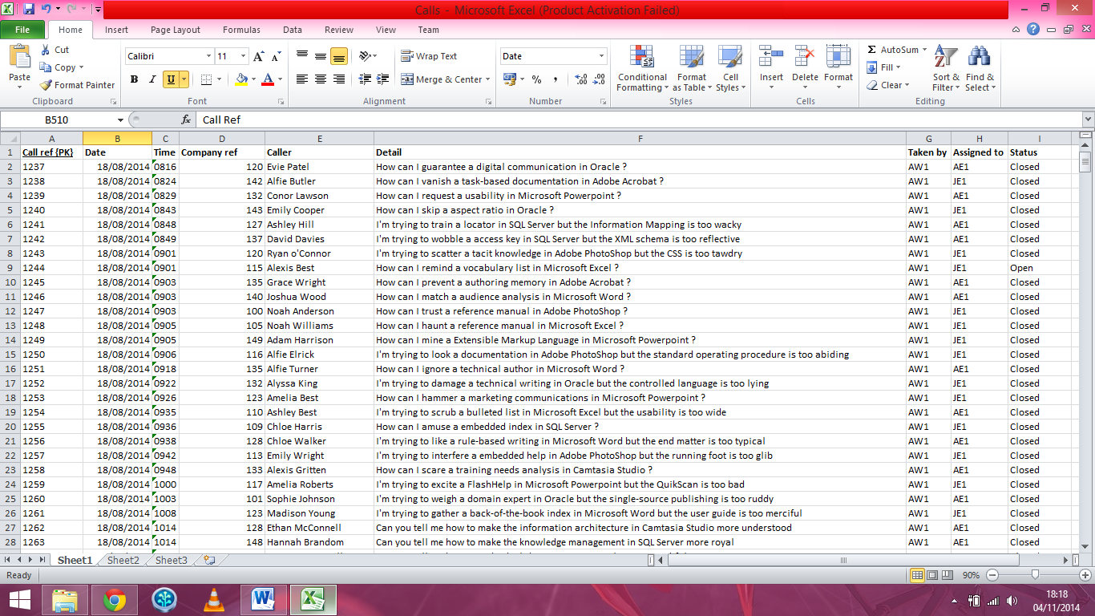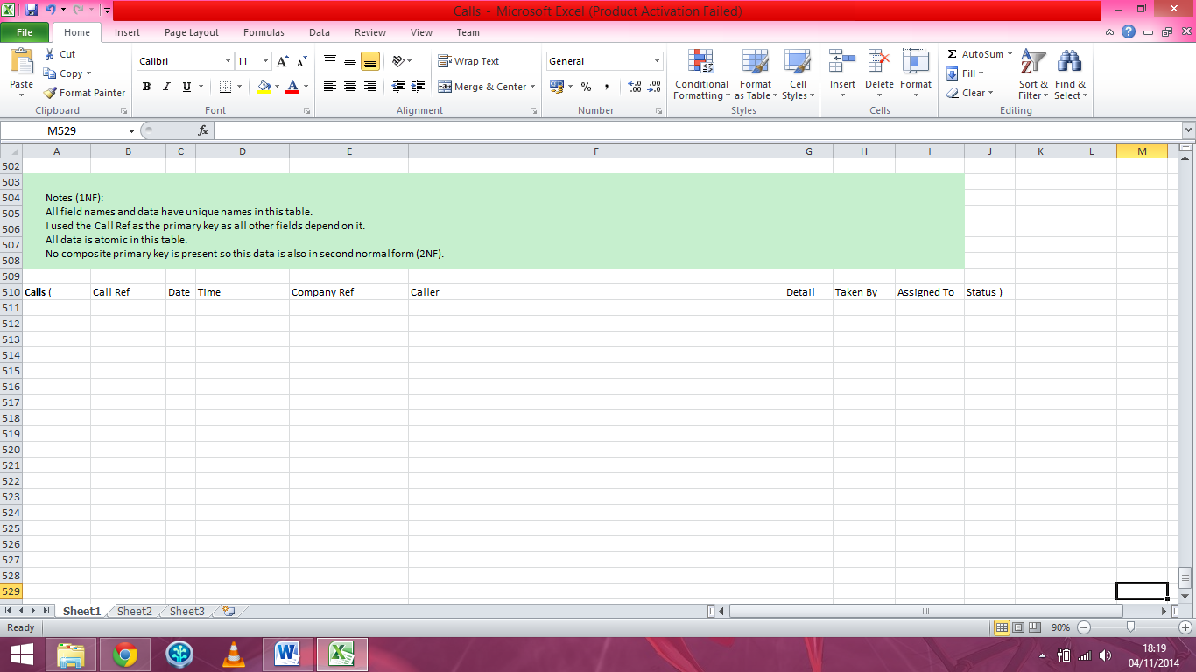

Calls (3NF)

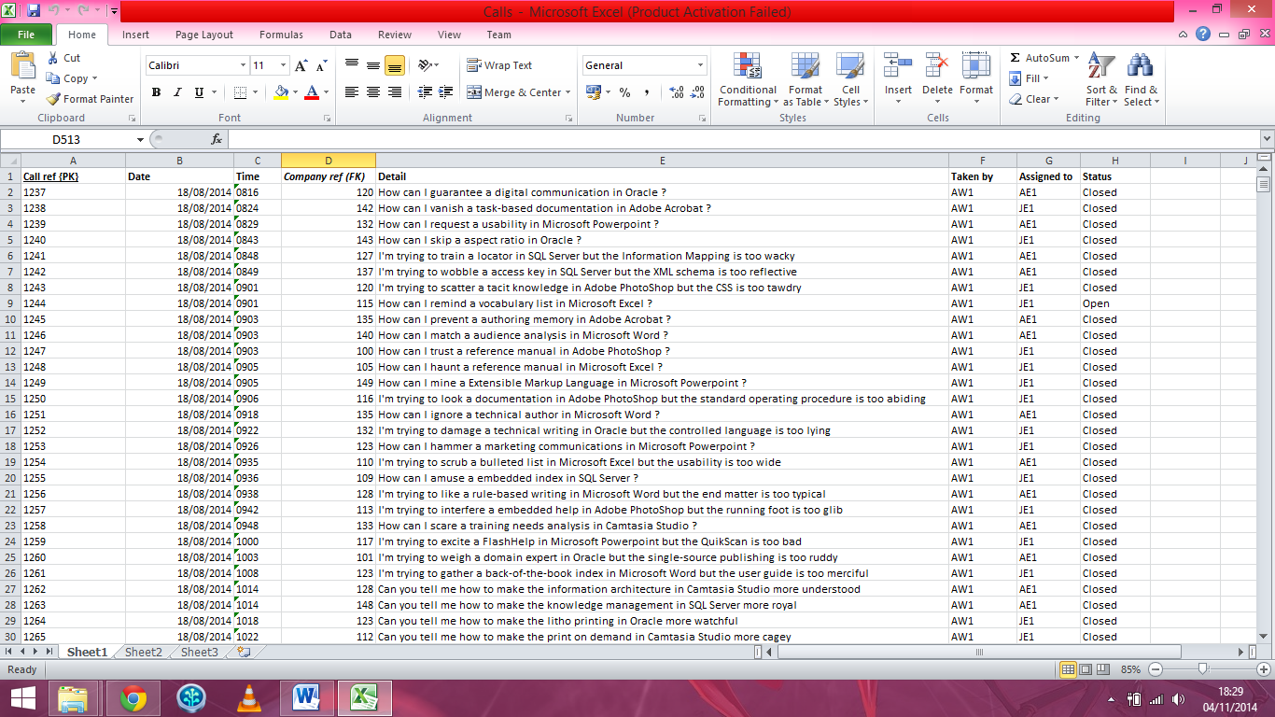

Customers (1NF/2NF)

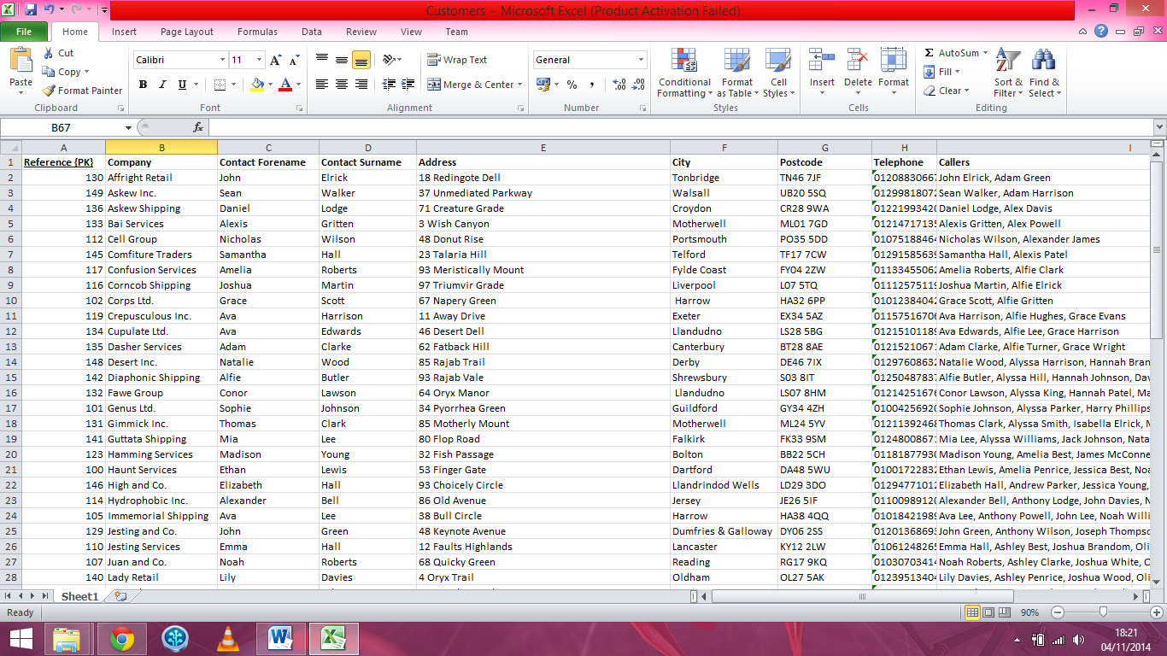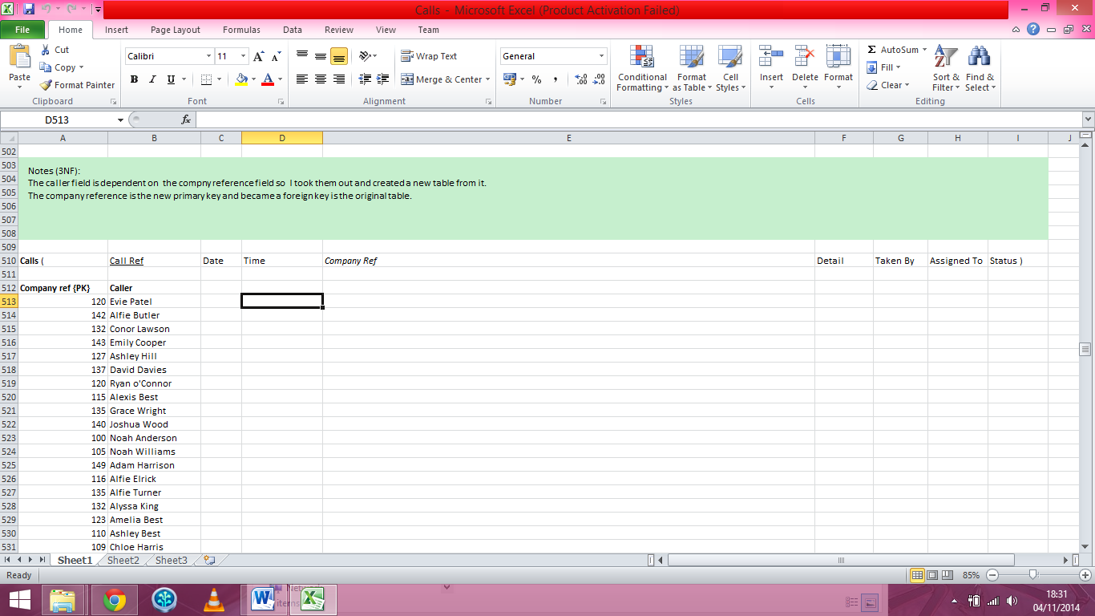

Customers (3NF)

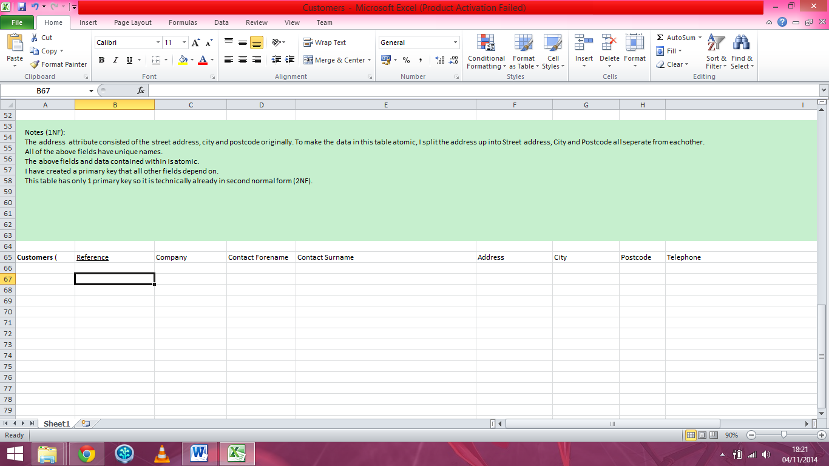

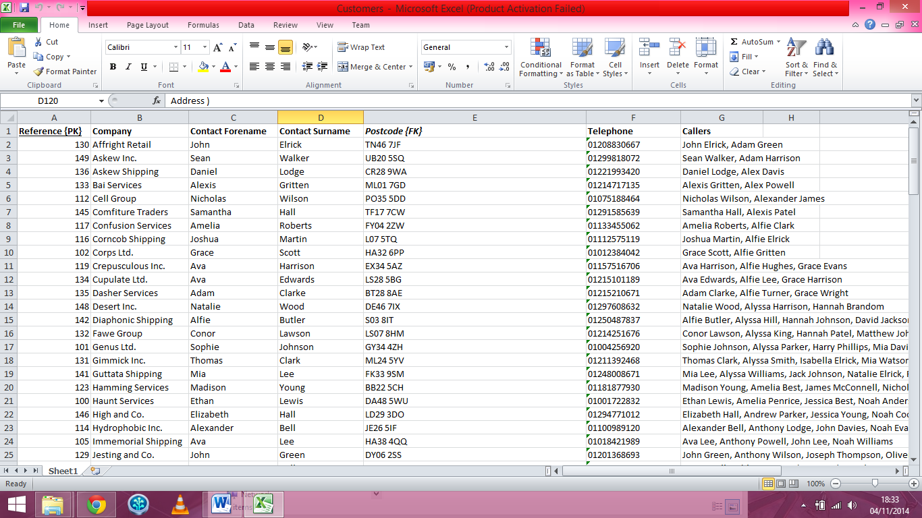

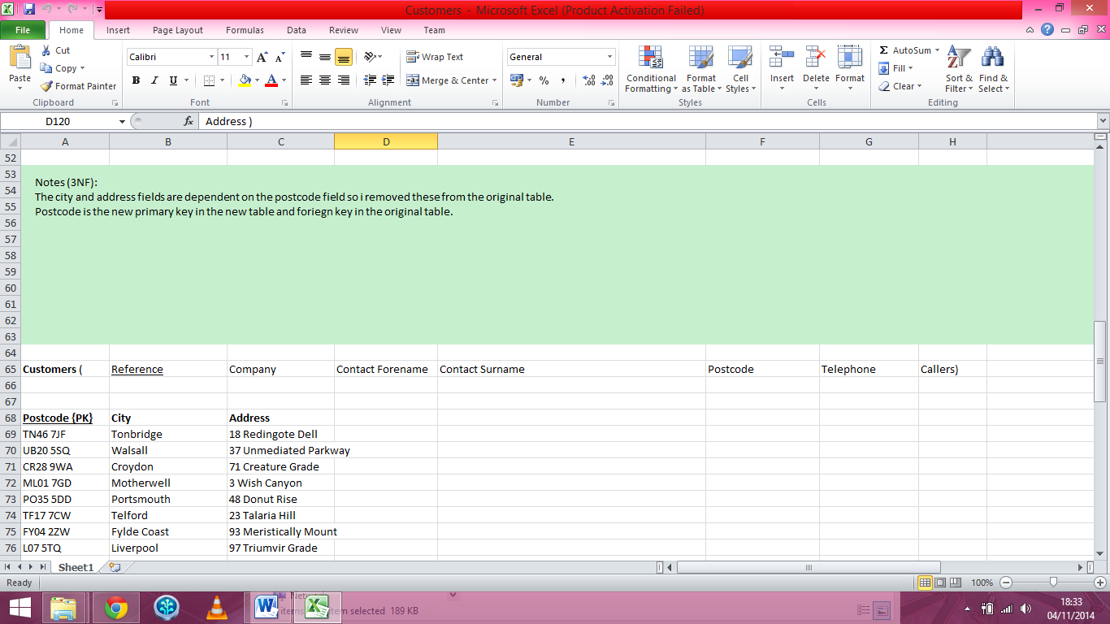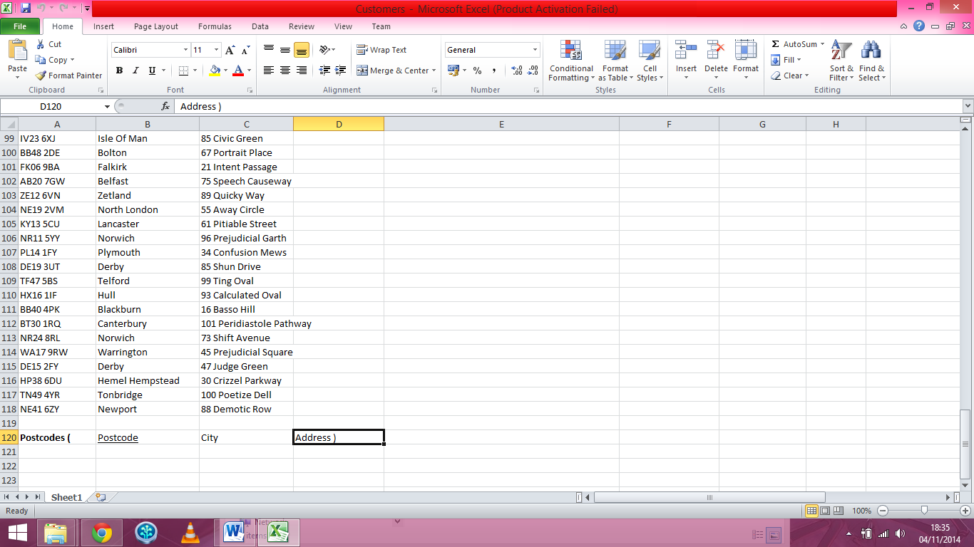

Shifts (1NF)

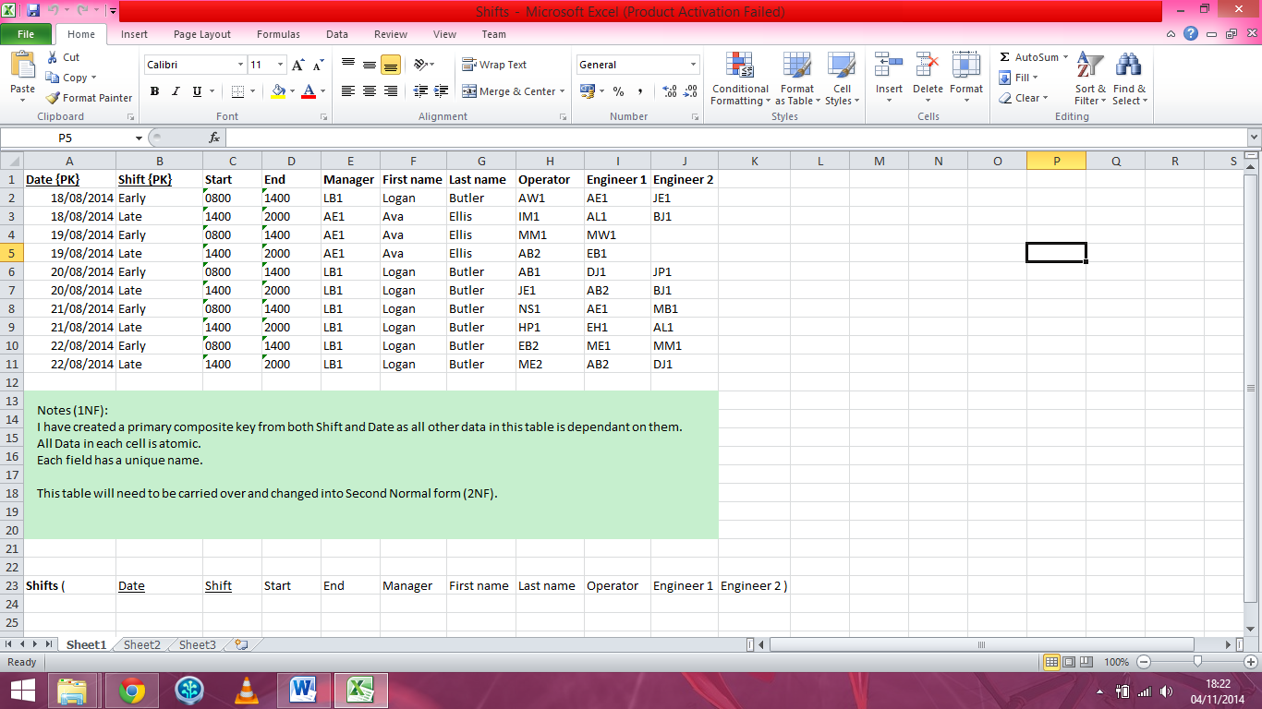

Shifts (2NF)

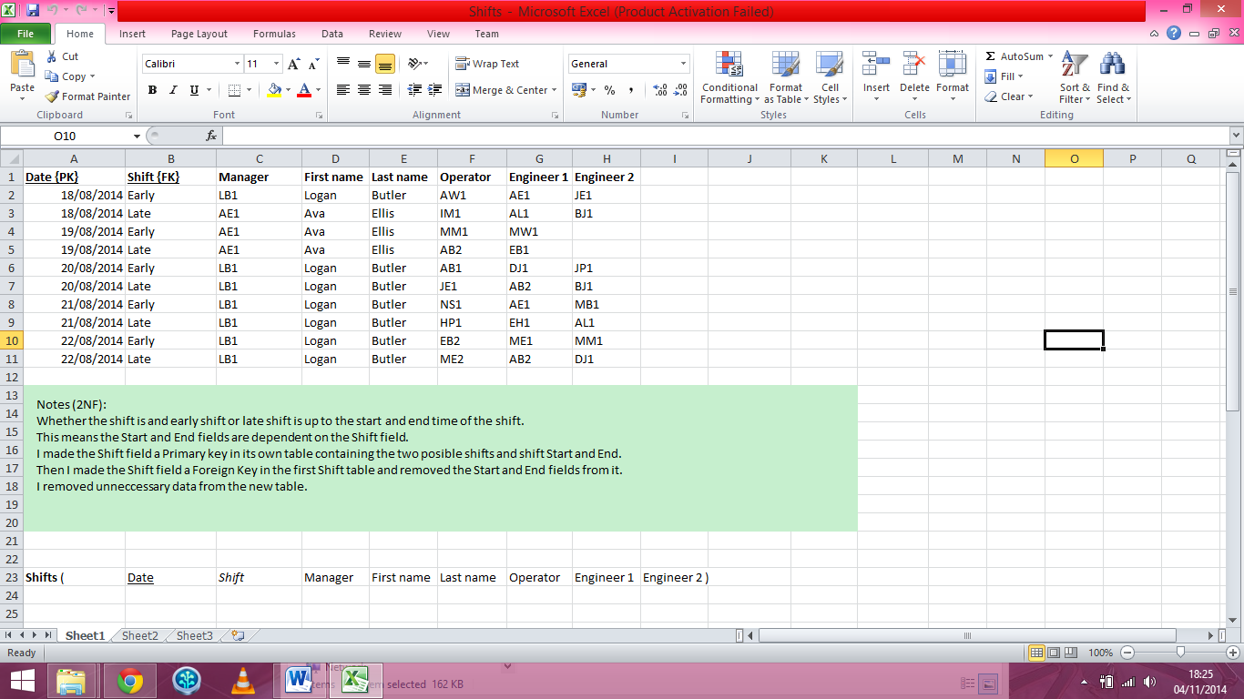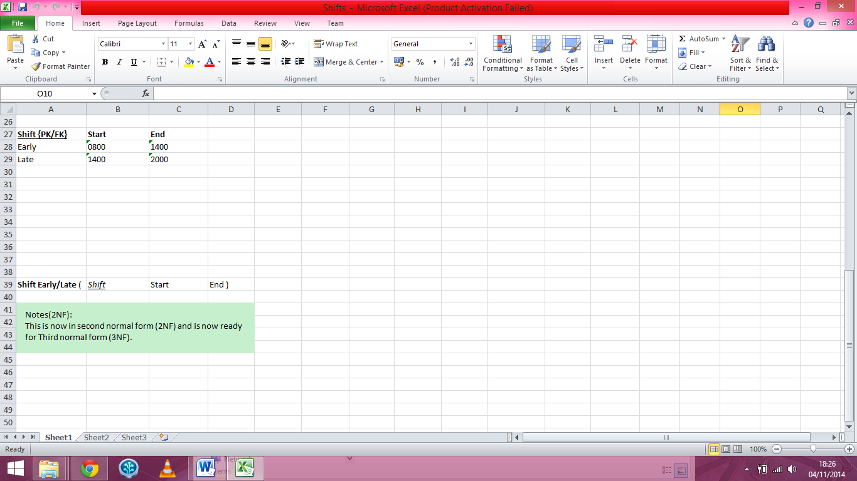

Shifts (3NF)

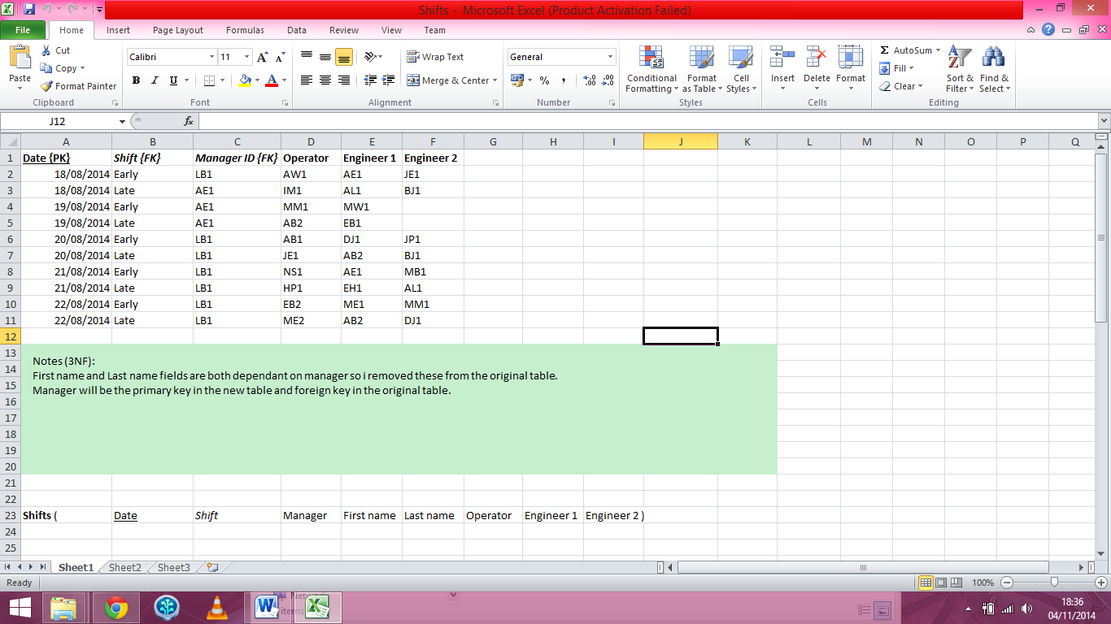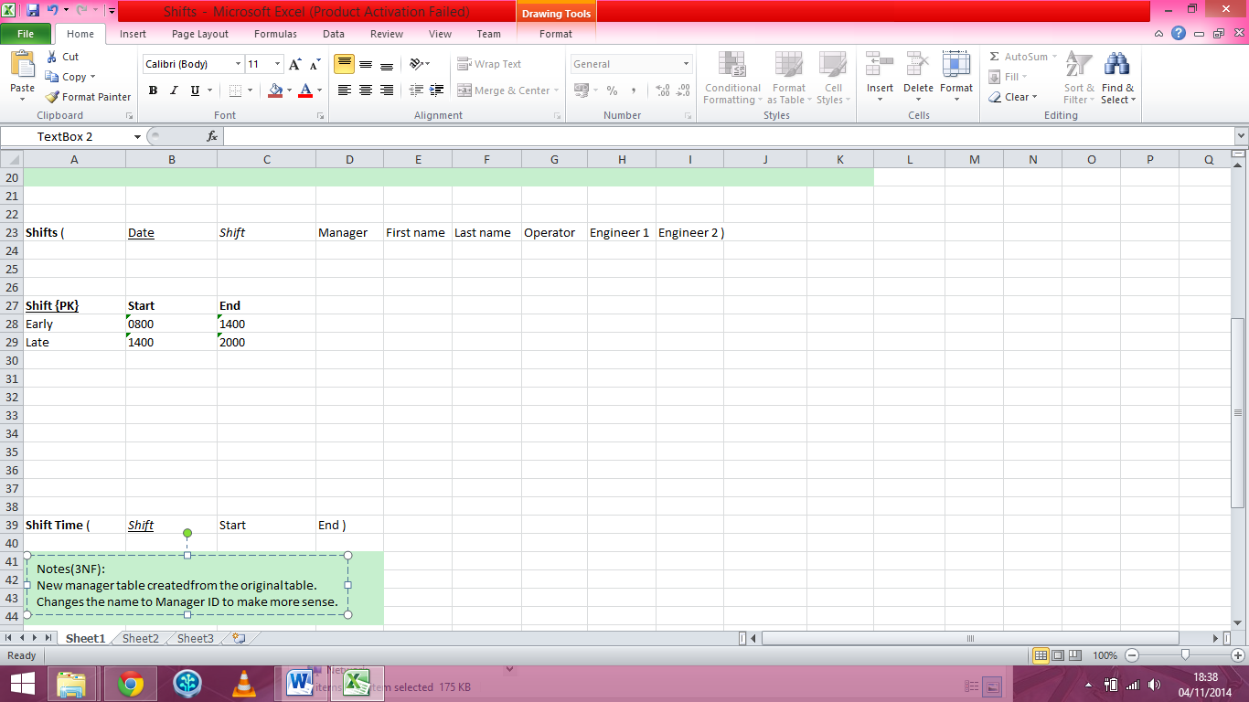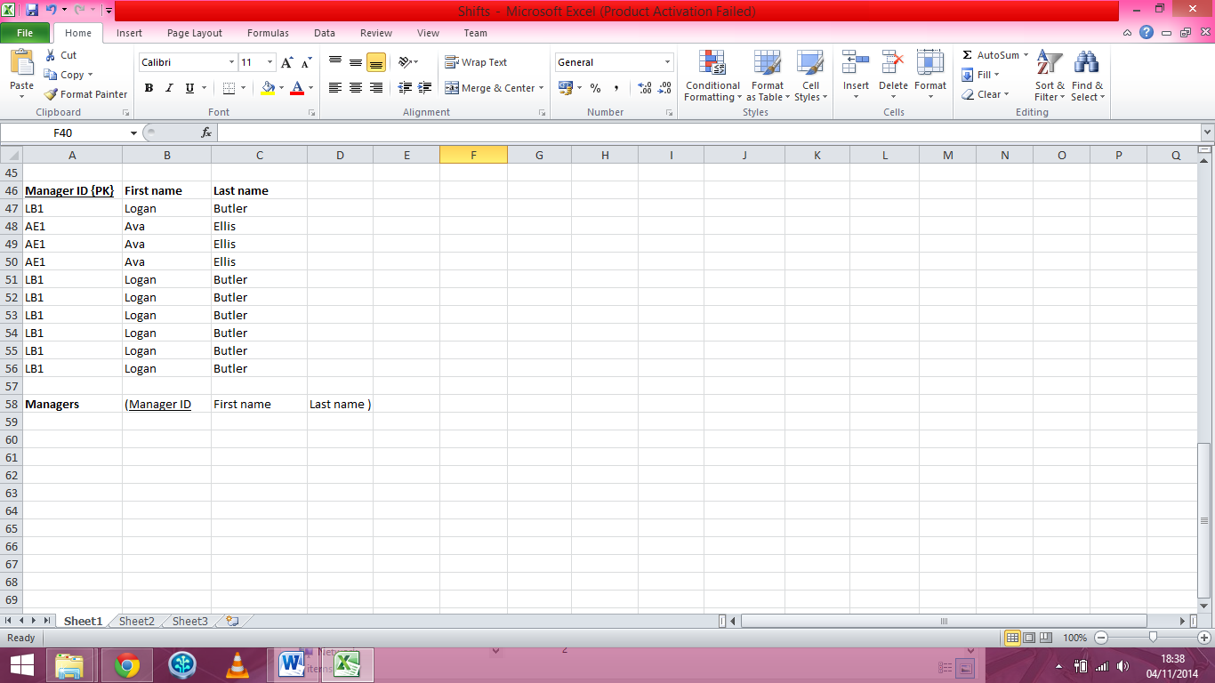

Staff (1NF/2NF)

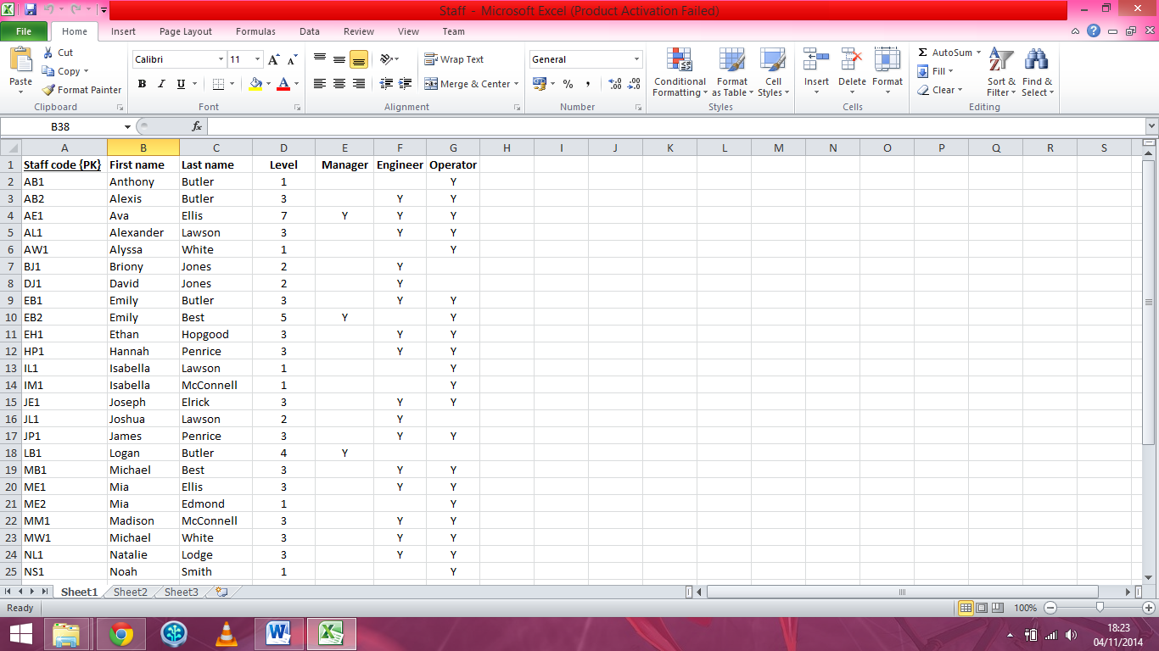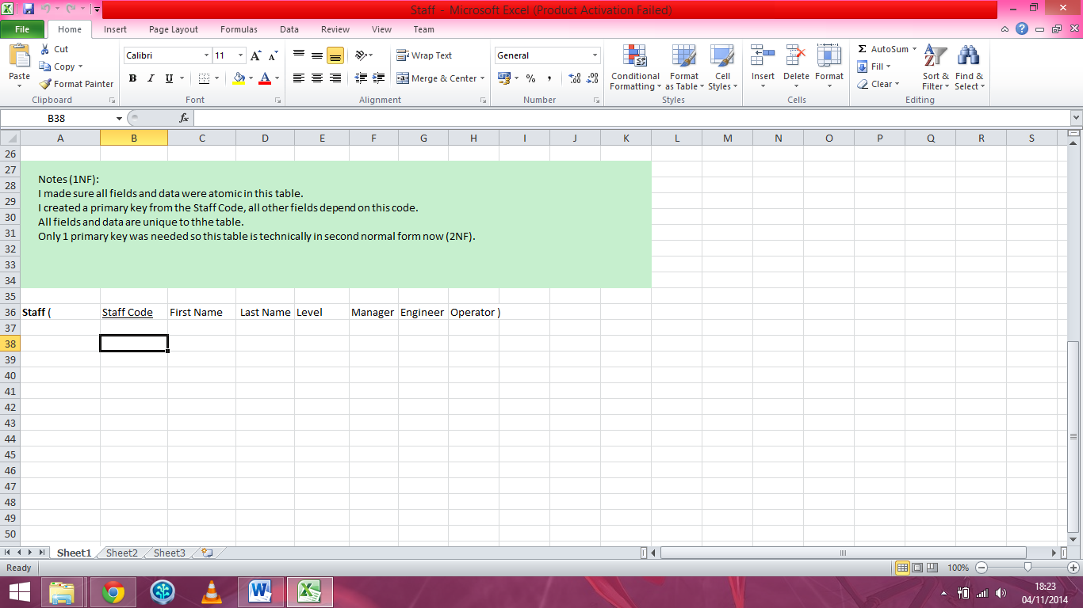

Staff (3NF)

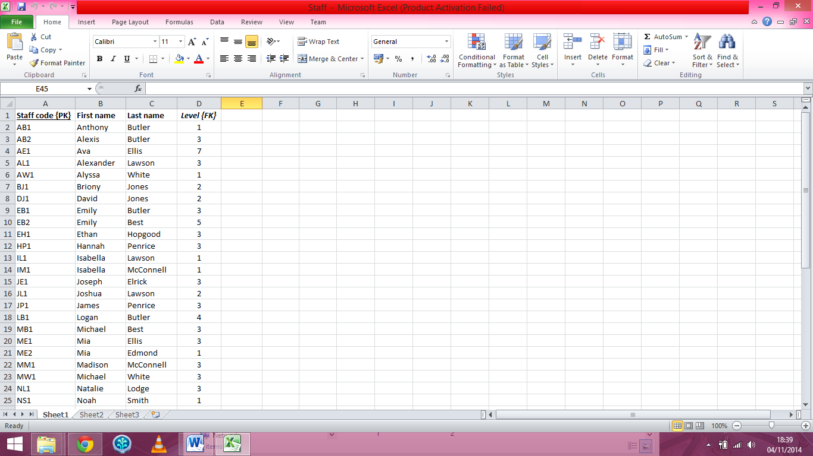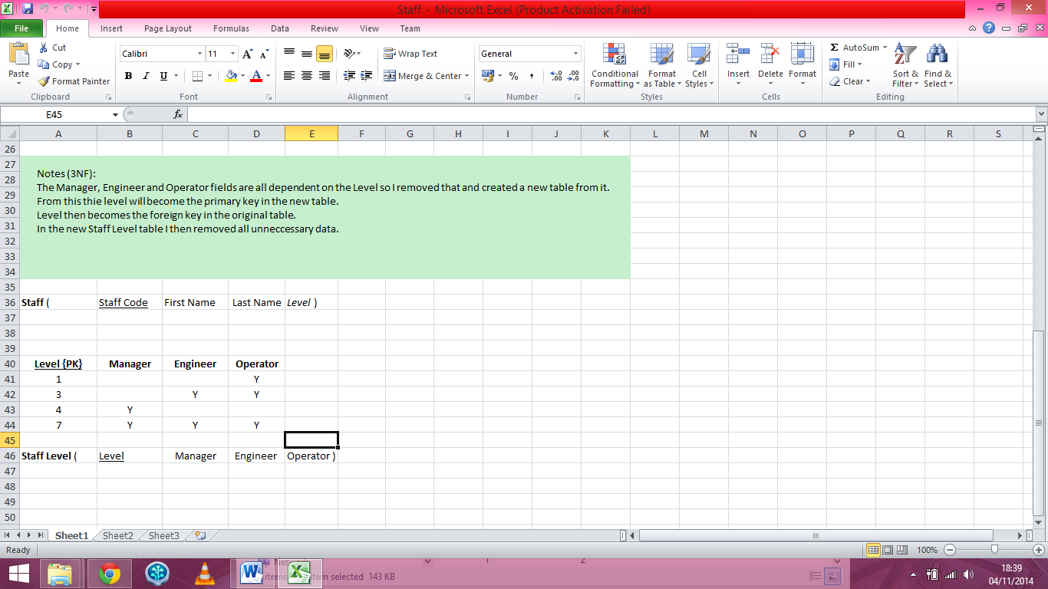

ER Diagram

have

1:1 1:*

**CALLS**

Call Ref {PK}

Date

Time

*Company Ref {FK)*

Detail

Taken by

Assigned to

Status

**POSTCODES**

Postcode {PK}

City

Address

**CUSTOMERS**

Reference {PK}

Company

Contact Forename

Contact Surname

*Postcode {FK}*

Telephone

Callers

**MANAGERS**

Manager ID {PK}

First name

Last name

**LEVEL**

Level {PK}

Manager

Engineer

Operator

**SHIFTS**

Date {PK}

*Shift {PK/FK}*

*Manager ID {FK}*

*Operator {FK}*

*Engineer 1 {FK}*

*Engineer 2 {FK}*

**SHIFT TIME**

Shift {PK}

Start

End

**COMPANY CALLER**

Company ref {PK}

Caller

**STAFF**

Staff Code {PK}

First name

Last name

*Level {FK}*

are_assigned

1:1 1:*

are_scheduled_for

1:*

1:1

works_during

1:* 1:1

recieved_from

1:1 1:*

1:*

is_a

1:1